Stagecoach Inn at Cairndow

i. General

The Stagecoach Inn is owned by Dougie and Cathy Fraser. They remember the recent phases of works as follows:

- 1977: due to fire regulations the access for the internal stair/ turnpike had to be completely enclosed from the main door.

- before 1979 the dining room was partitioned off. These partitions were taken out in 1994 to open up the present dining area. The lining of the bar and lounge area had already been in place by the time Dougie took over the Inn.

- 1979: the petrol pump was moved from across the hotel to the most recent spot further E; the pump was removed from its latest position there in 2010.

- 1981: the stables to the E were linked to the hotel, the kitchen extensions were added to the rear, and the toilet block to the front.

- 1983: the flat was put in above the restaurant, to E of original house.

- 1989: the house was added to the E, and the hydroboard shed to the E was demolished. It had served as a garage for hydro vehicles, allowing for overnight parking and had 3 to 4 doors on the E side.

- 1994: the most recent extensions and works included the demolition of the outside bothy and cellar and WC for pubs. These were used as workers’ accommodation. The outside toilets had been to the rear / E side.

Donald McPherson has been mentioned to know more detail about these alterations. He could also describe the arrangements of two chimneys at either end serving fireplaces and the layout of the beer cellar.

ii. External elevation and phasing

Although the Stagecoach Inn is quite a rambling complex incorporating many earlier elements, and has been extended a number of times in recent years, the core of the building is the Inn itself which is a handsome and well proportioned building of 2.5 storeys, likely to be rubble built and harled over by what appears to be of late 18th century or circa 1800 in date. Its principal elevation faces over the loch to the north. The Inn itself lies along the south side of the Cairndow village street. The main building is of a three bay arrangement, wholly symmetrically organised with relatively small windows, evenly spaced in the frontage and the principal ground floor entrance centrally positioned. The windows are detailed with raised margins of polished ashlar and these with a characteristic rounding of the inner arrises, again suggestive of perhaps a later 18th century date. The principal entrance is also of similar detail with raised margins.

The second floor level is lit by three windows that are half within the wall top and the upper part formed into dormers. Their slated roofs are hipped, these with slated sides and wooden fascia boards. It is possible that these upper parts are secondary extensions and there are some patchings on the lower part of each window suggesting that there had been small windows rising up to the wallhead rather than breaking through the wallhead originally.

The building is relatively deep in plan. Its roof is double-pitched and slated with Scots slates. The gables at either end are finished with skews and moulded skew putts of cyma profile. The gables rise up to chimneys, each containing three flues. The gable walls are most obscured by later additions. At the first floor in the east gable there is a small window that seems to be a secondary insertion; it is offset to the north and a second floor window, also apparently an insertion, offset to the south.

Photographs of late 19th century or early 20th century date kept within the building show that there had been a small single-bay extension extending westwards from the west gable wall of the main building. This still survives although it has been extended considerably to the west. The earlier single bay extension was harled externally as elsewhere and the windows within it are bigger than those of the main building. This suggests that this is a secondary addition, probably of 19th century date.

On the principal frontage of this extension, facing the loch to the north, these windows had been of sash-and-case form and the upper one breaking the eaves to form a half dormer. This existing dormer has a double-pitched slated roof with wooden fascias and slated sides although all of this appears to be a modern reconstruction. The roof of this little extension had been hipped to the west. A further building including the cellars of the Inn had existed, a range north/south aligned and lying a little bit beyond the west end of the main building and its extension, there being a little gap between the two. It appears that this further north/south aligned range was either wholly demolished or very substantially modified and the main building was extended to form a single, continuous range, L-shaped in plan.
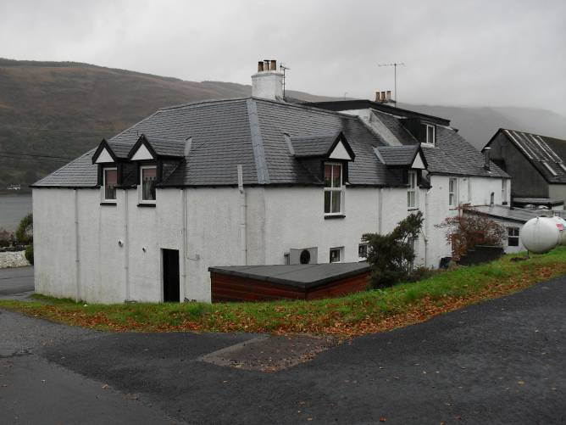
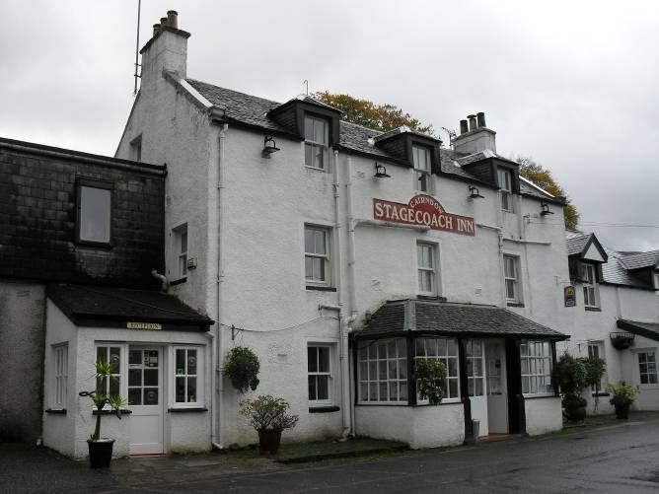
Figure 35 and 36 – Cairndow Inn original part with 19th century porch (left), rear elevation (right).

The frontage of the original main building is now partly obscured by a single-storeyed porch, this perhaps of two periods. The central part appears to be of late 19th century date and consists of a porch supported by four wooden piers, these with typical Victorian detail. The wooden piers have chamfers that come down to plain stops although at the wall that forms the external side of the Inn building, it appears that these chamfers terminate as lamb’s tongue stops. This porch arrangement may have been open originally, and seems to have been infilled and extended out to either side with low flanking walls and glazed infill above, these of four-by-three configuration – the windows with a slated roof over, culminating in a lead flat at the top and with hipped ends.

All of the windows in the main frontage of the main building are of sash-and-case form, two-above-two, but all are of modern PVC, with double-glazed detail.

The rear extension contains slightly curious detail; the line of the gable wall of the main building contains a slight step back whereas the west wall runs through to the west wall of the main building. Early photographs showing the west wall depict a double-pile arrangement with a valley in between. This was subsequently modified and there is now a flat roof spanning between the two inwards facing pitches. The rear extension had also had a chimney stack at its gabled west end and this was removed when the flat roof was put in. (Tape record deteriorates badly at this point). The rear of the building contains a number of windows at level three and a series of flat roof extensions relating to the existing kitchens, these to the SE corner at rear. The windows upstairs in the south wall and in the east wall have no margins, the harling simply going over it. The upstairs window at the west end of the south wall retains a margin but the tooling details are apparent, suggesting it is not as early as those of the main building. The arris is not rounded but sharp. Neither of these rear extensions are as early as the main building. It is also clear from the earlier photographs that the westwards extension, the gable wall of the main building which was of single-bay width with a hipped roof was paired with a second extension of identical form or similar form, extending from the west wall of the rear extension to the main building itself. This also had a hipped roof detail.

iii. Interior

The building is entered through the porch, which is detailed with glazing bars that are of simple, chunky chamfered profile. The entrance itself is through a door with a two-by-three window arrangement. An early photograph apparently of late 19th century date kept inside the Inn shows the porch before the later modifications. It is a freestanding structure, open-sided upon its wooden piers. It has a double-pitched slated roof which is pedimented towards the lochside to the north. Its apex at this point surmounted by a pointed wooden finial.

The turnpike stair at the back rises up to a first floor landing. The stair contains typical 1760s-1770s detailing.This is a fairly narrow space, east/west aligned, and had originally had four entrances off it. An entrance to the east leads into a principal room occupying the entire eastern bay of the original building. Two entrances lie to the south, one of which led into a central bedroom, possibly somewhat smaller, and a box bedroom. The wall separating the eastern and the central bedrooms has now been removed and two en-suites put in their place. However the cornice work of the eastern room can still be seen on its south side, defining the limits of that space, as it had been.

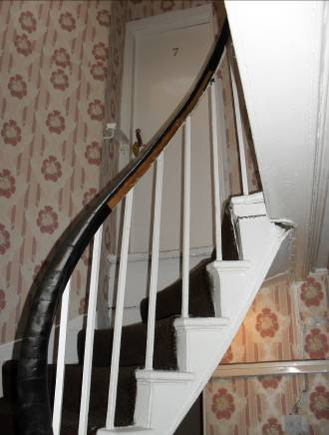
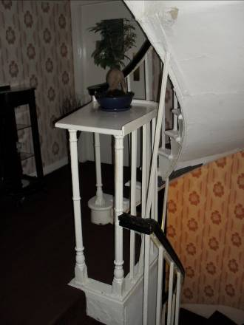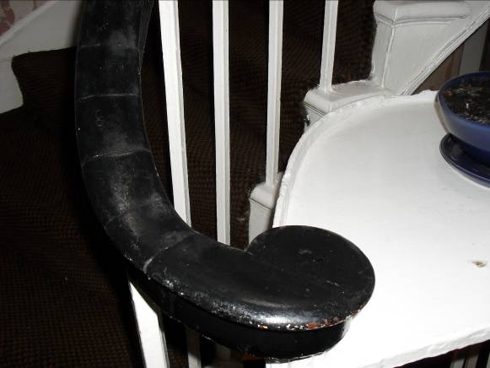
Figure 37, 38, and 39 – stair details: railing at first floor landing (left), handle detail (centre), stair to
second floor level (right).

Off the landing, in its north wall, towards the west end is a further entrance, this into a large room occupying the west end of the main building. Of all the upper floor chambers, this is relatively well preserved, retaining its cornice and a fireplace in the gable wall to the west. This fireplace, of typical 18th century detail with no mantelshelf, is formed of two upright stones and a lintel over. There is an outer ovolo moulding and an inner cavetto moulding that can still be seen. There had been a substantial recess at the south-western corner of the room and this evidently or likely to have been a bed recess. This has now been walled off with a later studwork partition but clearly the cornicework ran into this area.

Off the stair landing on its west side is a further entrance and from the cornice scars etc within, what is now a large linen press, it is clear that this had originally been a small shelved press. The architraves of all of the entrances off the landing are of similar detail with a narrow quirked angle roll, inner and outer. This repeated on the architraves within the rooms themselves. Although the windows themselves have been replaced throughout, in the upstairs room to the south-east the shutters still remain. These contain raised and fielded panels and what appears to be a double ovolo detail although very heavily painted out, as the moulding detail.

In the eastern first floor room in the east wall, there had been a fireplace, of which the scars, the cut skirting and the hearth stone are still apparent. On either side of this had been windows, the northern of which still remains, the western of which later formed into an entrance in recent years into a modern addition. The window within this room, in the north frontage, still retains its original shutters with its raised and fielded panels. The central and first floor window on the north side also retains its original shutter panels and architrave. In the east wall of the first floor room, the window to the north was a modern insertion, circa 1981, put in by Fergusons of Strachur, at a total of £30,000. The central, original first floor room was fairly small and was not furnished with a fireplace, there being no flue-bearing walls.

At ground floor level within the main building, it is clear that the eastern part of the building was formerly a single, interior space. There are remains of early cornice work to the east, south-west and along the south wall, still surviving. Until relatively recently, this interior was wholly partitioned off from the rest of the ground floor although subsequently opened up. Other early features that survive in this area, at the south end of the east wall there is a broad, splayed ingo for a former window, architrave still remaining; this with a narrow, inner, quirked roll and an outer cyma moulding. The window on the principal frontage to the north retains its original window shutters, these with raised and fielded panels and parts of its architrave also remain. There had also been a fireplace in the centre of the east wall, the hearth stone of which can still be traced, but otherwise blocked off and covered over. The remainder of the ground floor interior has been very substantially modified and covered over. So much so there is little evidence as to the details of the original arrangement although one had probably entered into a small entrance passage with doors off to the principal ground floor rooms to east and west. The walls to the west had been wholly removed and within the western room there are very few surviving early features. The fireplace and chimney breast in the centre of the west wall is probably the original although now heavily obscured and modified by later woodwork trimmings and red paint. However, the three stones that formed the fireplace still remain but these have been heavily tooled back. No other early features or finishes are now visible within this interior. The whole of the ground floor was opened into an open plan arrangement. The walls are plasterboarded and lined out with applied timberwork to suggest half timbering and this all painted black.

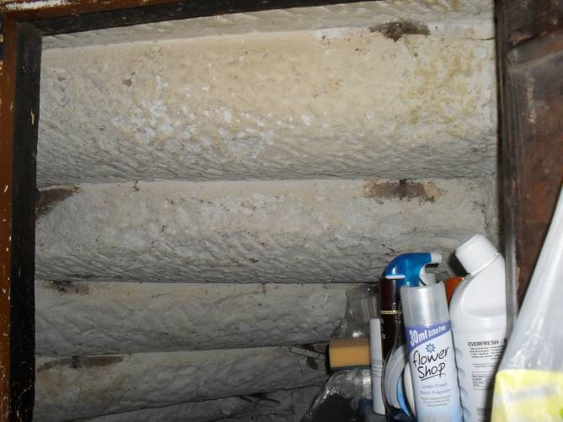
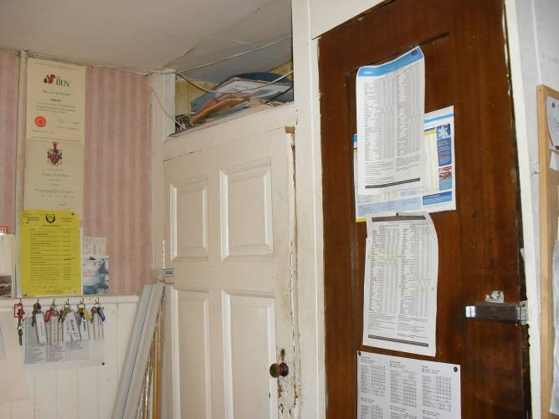

Figure 40 and 41 – re-used door in pump room (left), view underneath stair soffit (right).

Within the pump room at the rear of the building there is a press whose door appears to be re-used. This is a very good six-panelled 18thcentury door with raised and fielded panelling on both sides. It is detailed with a quarter ovolo moulding. The window within this room is one of the few sash-and-case windows of the rear elevation. This appears to be of Victorian date, six-over-six, but detailed with horns, the glazing bar profile, is Victorian Gothic.

Additional note for the ground floor of the main building: To the east there is a principal joist running east/west, this offset slightly to the south suggesting the possibility that the southern part of this eastern area of the building had itself been partitioned off. The only other early feature within this area is a small window which had originally been to the exterior, now into the kitchen to the east.

The principal staircase lies at the rear south side of the building. This is of curious detail, rising up through a quarter-circle within a quarter-circular rear tower or extension. Within this the stair itself is of a stone flight rising up to a quarter-landing through a quarter-circle. On the inner side is a balustrade of wrought iron verticals with cast iron newel posts at the bottom. These are of clustered columns, very batty, Langley in style. The handrail itself appears to be mahogany and comes down to a characteristically curled terminii. The stair rises up to a quarter-landing; thereafter there are two steps up to the main first floor landing within the principal range and two steps up into what had evidently been a rear wing. To the west are also four steps up that lead up to the additional buildings beyond which are all likely to be of later, secondary date.

Between the first and second floors the stair resumes a much more coherent semi-circular series of steps all formed of timber. These rise up to a stair, to the second floor landing. On the second floor landing there had likely been a fairly similar arrangement of entrances and chambers beyond. Only two entrances now survive, one in the west end of the north wall and one to the east. A patching of the skirting at the east end of the north wall suggests a third one at that point. No obvious sign now of a door on the west side.

To the east of the original main Inn and set further back from the road frontage further to the south is an east/west aligned range which was the former stables. This has now been very substantially modified and extended and is now unrecognisable as the earlier building having been re-roofed as well.

